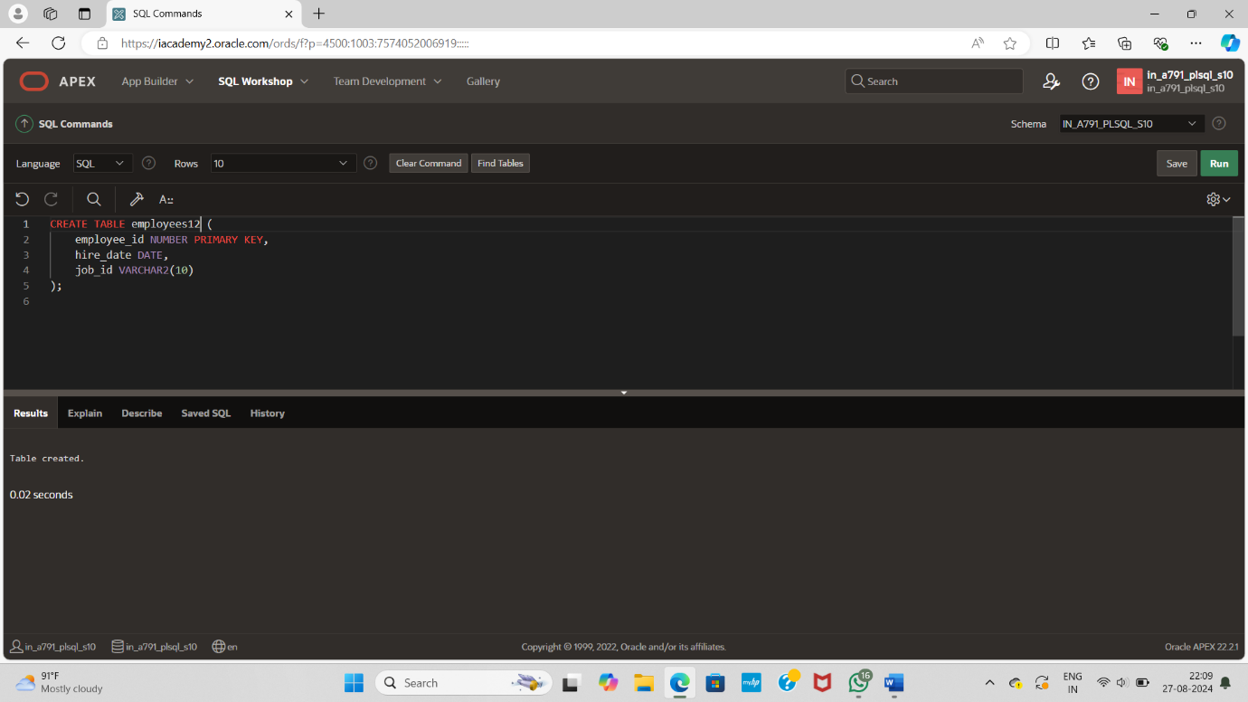

CREATE TABLE employees12 (

employee_id NUMBER PRIMARY KEY,

hire_date DATE,

job_id VARCHAR2(10)

);

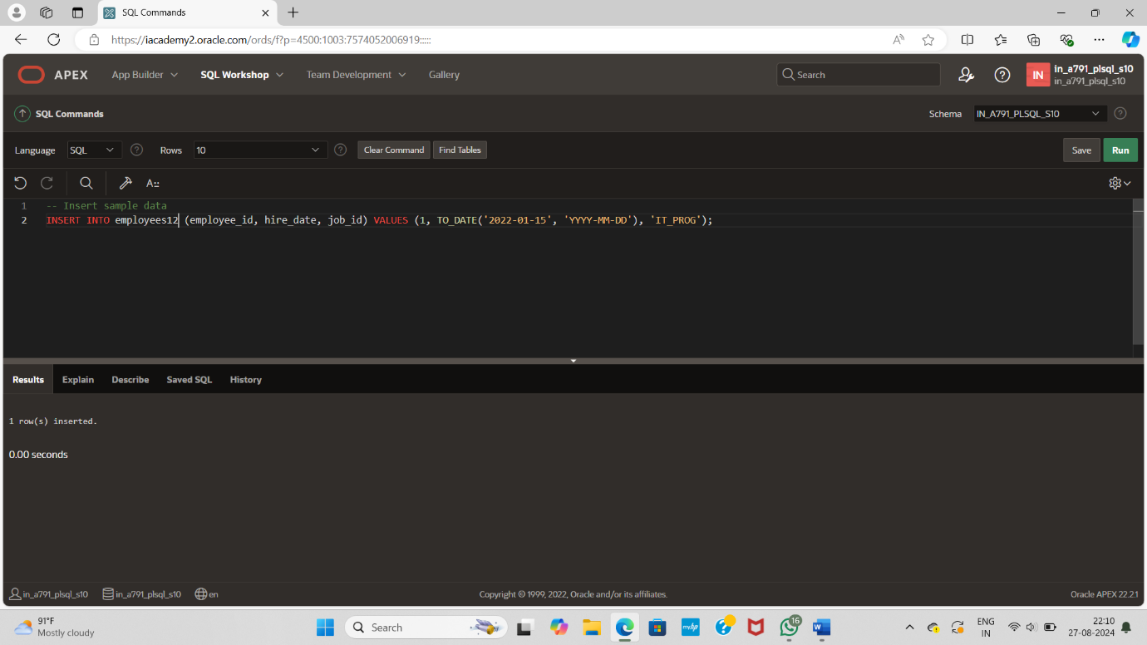

INSERT INTO employees12 (employee_id, hire_date, job_id) VALUES (1, TO_DATE('2022-01-15', 'YYYY-MM-DD'), 'IT_PROG');

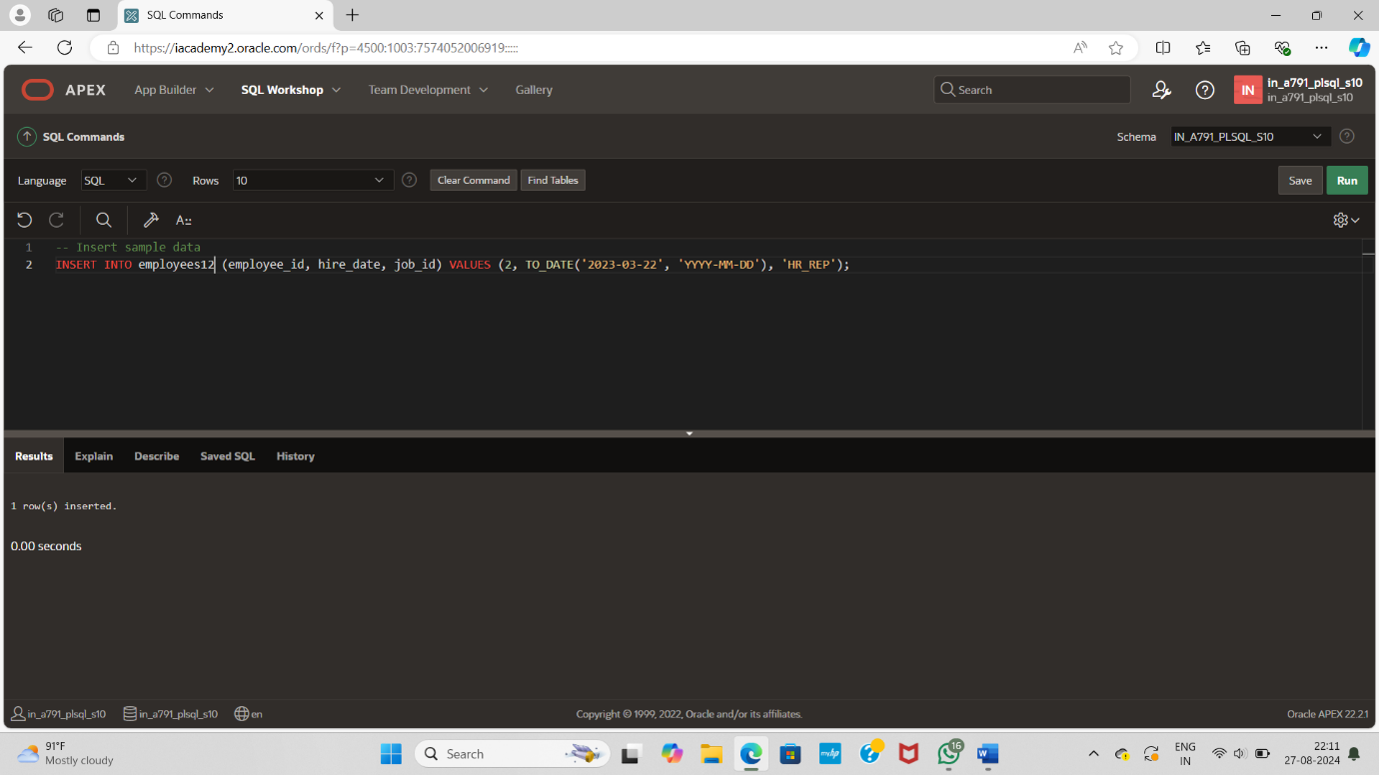

INSERT INTO employees12 (employee_id, hire_date, job_id) VALUES (2, TO_DATE('2023-03-22', 'YYYY-MM-DD'), 'HR_REP');

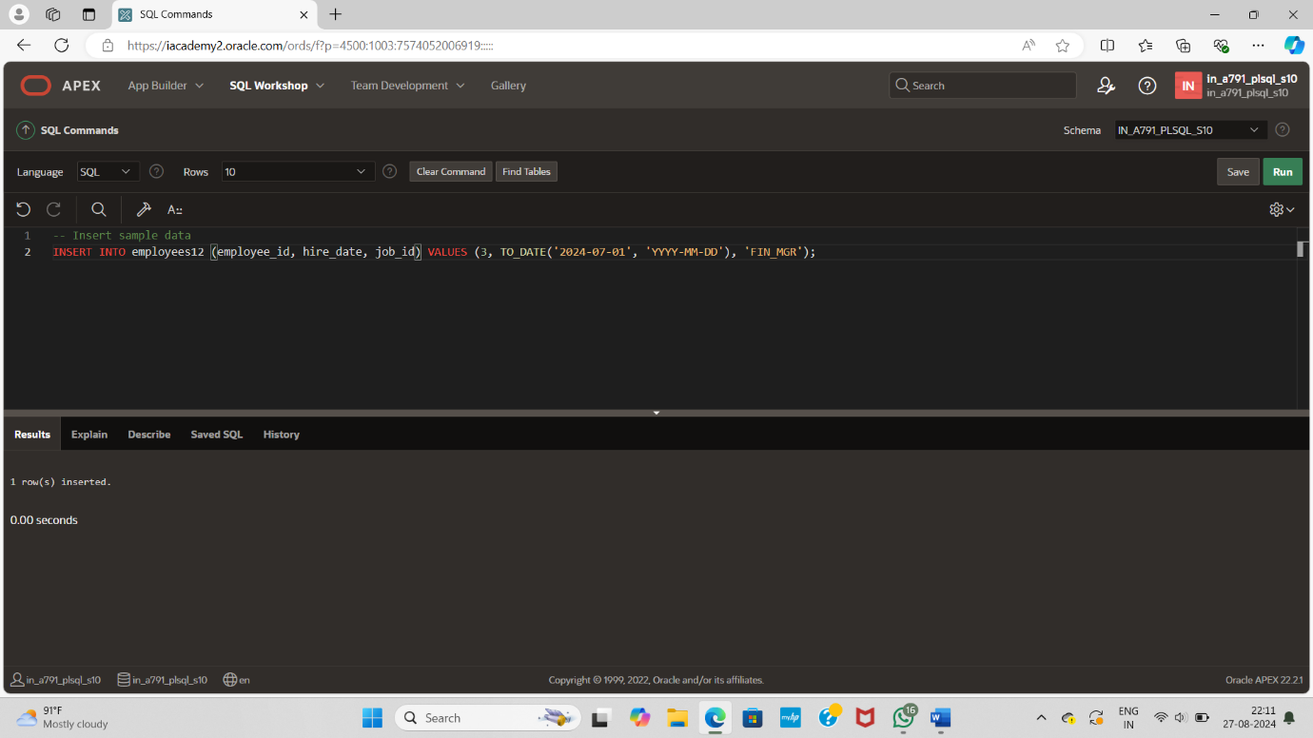

INSERT INTO employees12 (employee_id, hire_date, job_id) VALUES (3, TO_DATE('2024-07-01', 'YYYY-MM-DD'), 'FIN_MGR');

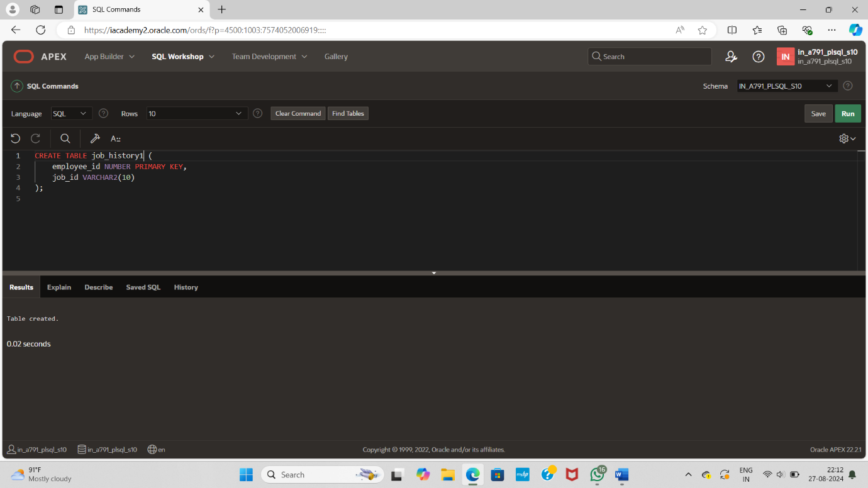

CREATE TABLE job_history1 (

employee_id NUMBER PRIMARY KEY,

job_id VARCHAR2(10)

);

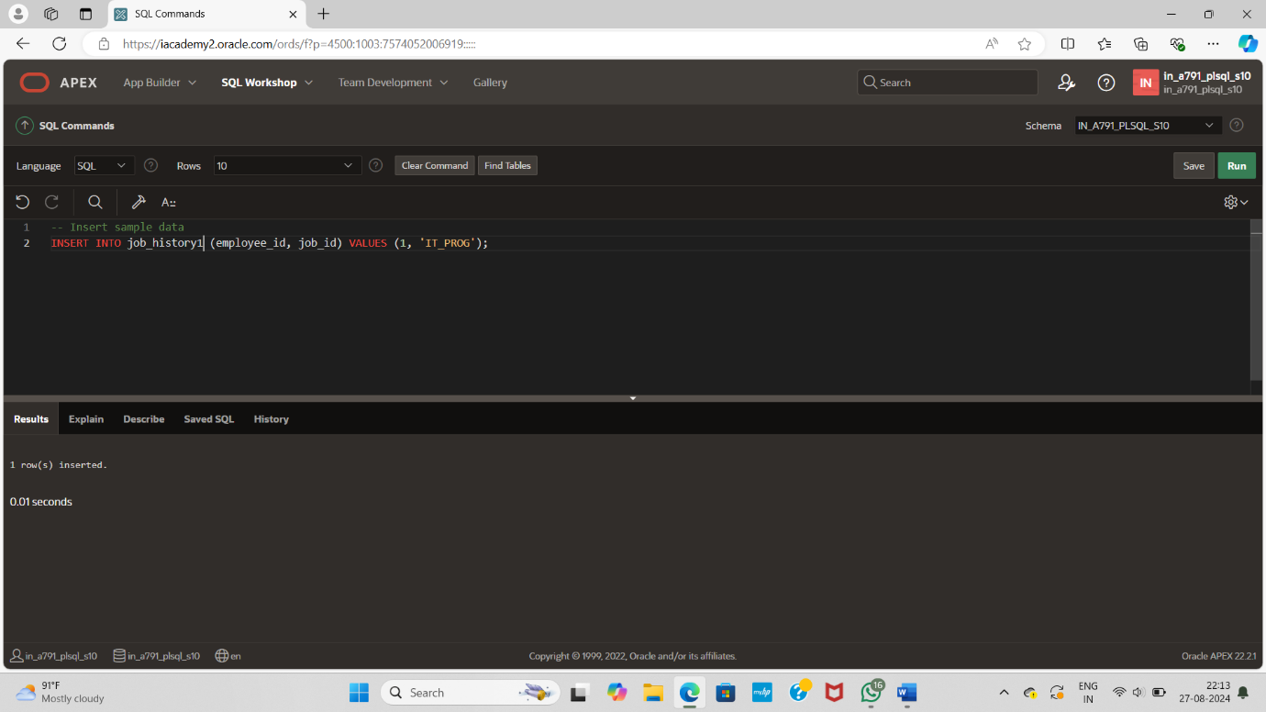

INSERT INTO job_history1 (employee_id, job_id) VALUES (1, 'IT_PROG');

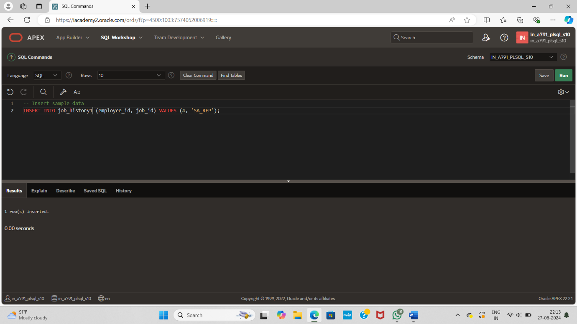

INSERT INTO job_history1 (employee_id, job_id) VALUES (4, 'SA_REP');

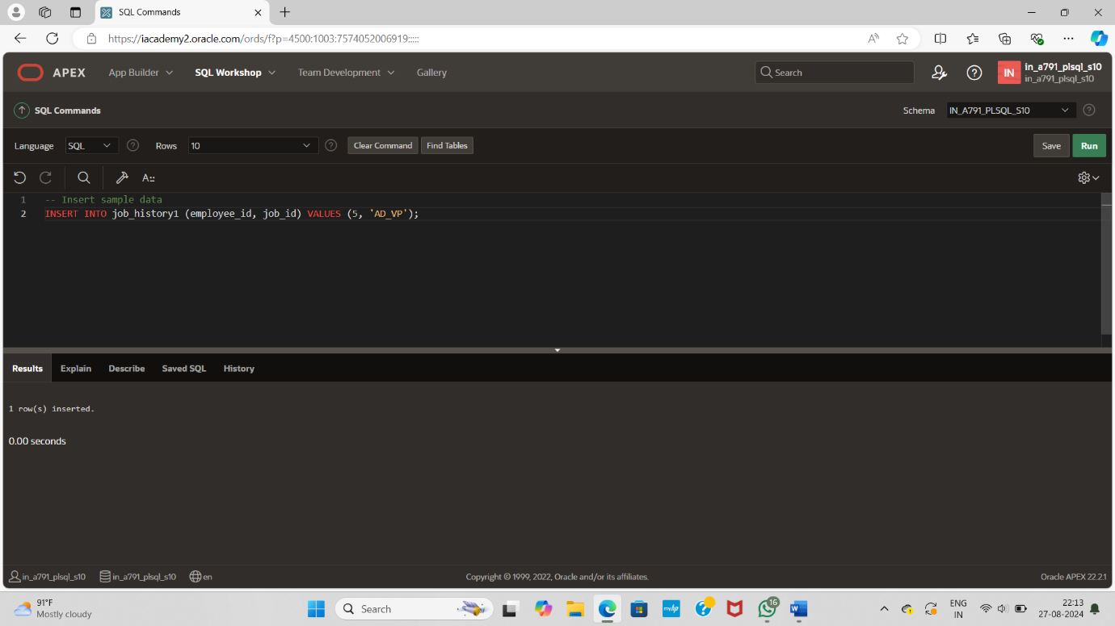

INSERT INTO job_history1 (employee_id, job_id) VALUES (5, 'AD_VP');